1. Write a MongoDB query to display all the documents in the collection restaurants

-> db.restaurent.find().pretty();

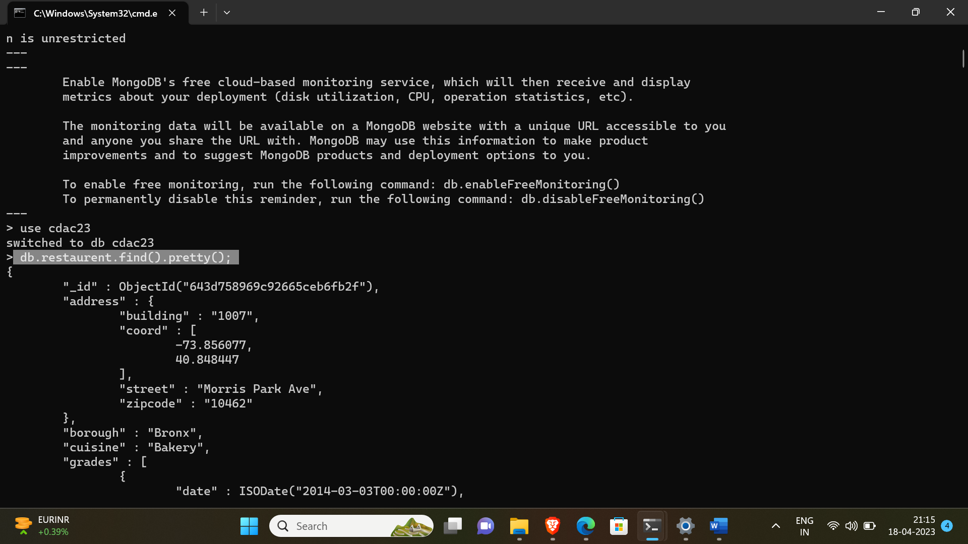

2. Write a MongoDB query to display the fields restaurant_id, name, borough and cuisine for

all the documents in the collection restaurant.

-> db.restaurent.find({},{"restaurant_id":1,"name":1,"borough":1,"cuisine":1}).pretty();

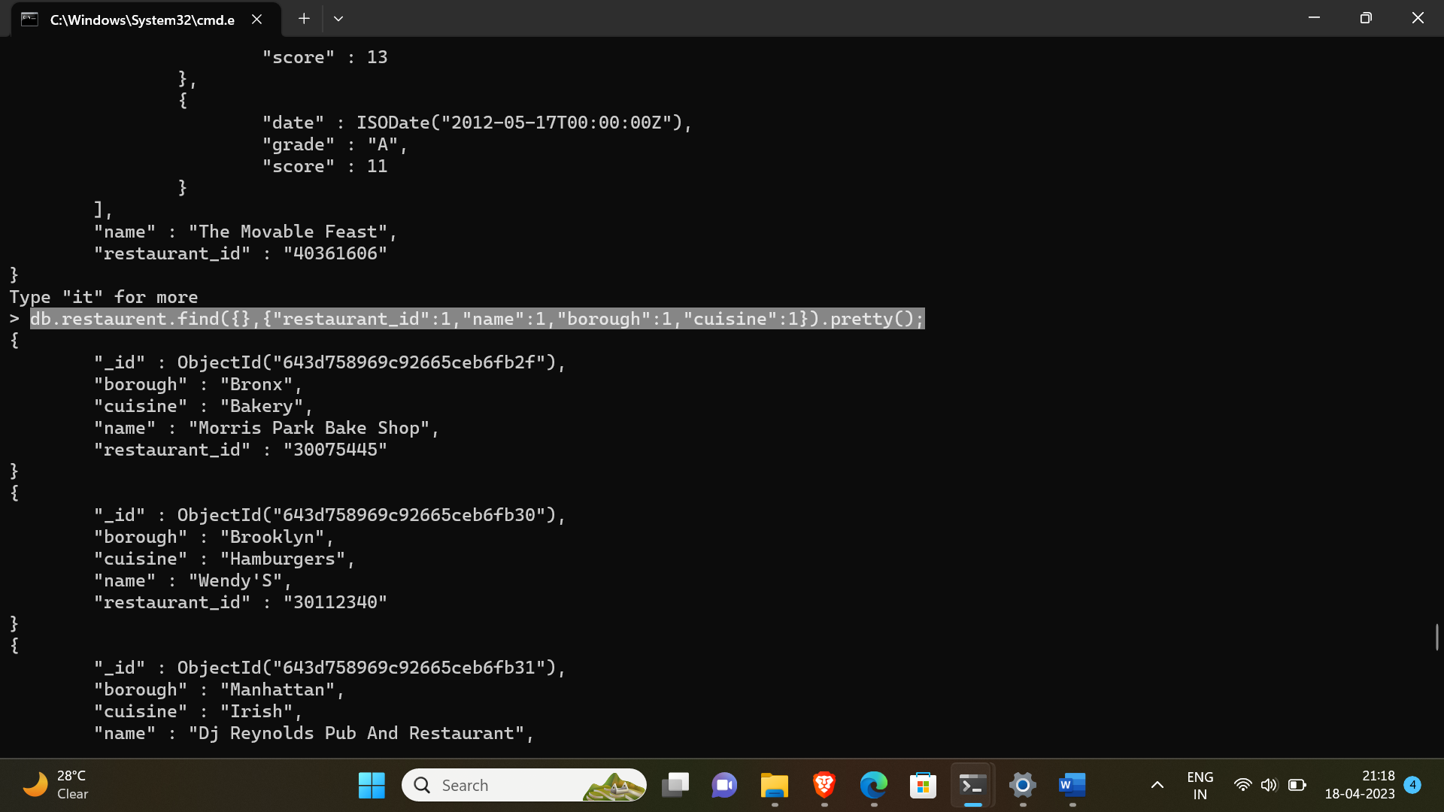

3. Write a MongoDB query to display the fields restaurant_id, name, borough and cuisine,

but exclude the field _id for all the documents in the collection restaurant.

-> db.restaurent.find({},{"restaurant_id":1,"name":1,"borough":1,"cuisine":1,"_id":0}).pretty();

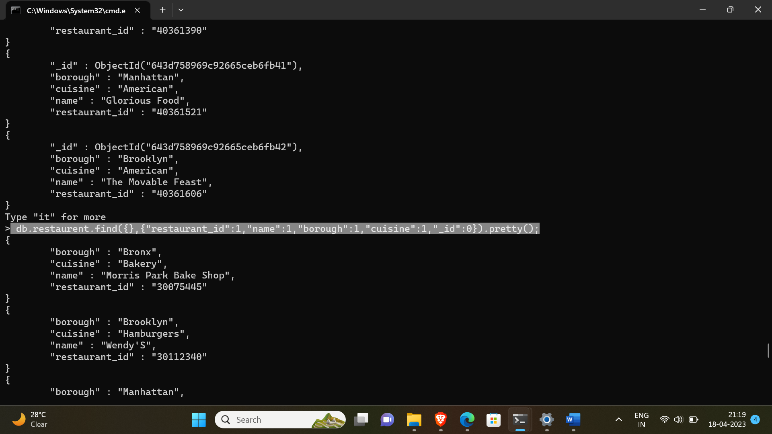

4. Write a MongoDB query to display the fields restaurant_id, name, borough and zip code,

but exclude the field _id for all the documents in the collection restaurant.

db.restaurent.find({},{"restaurant_id":1,"name":1,"borough":1,"address.zipcode":1,"_id":0}).pretty();

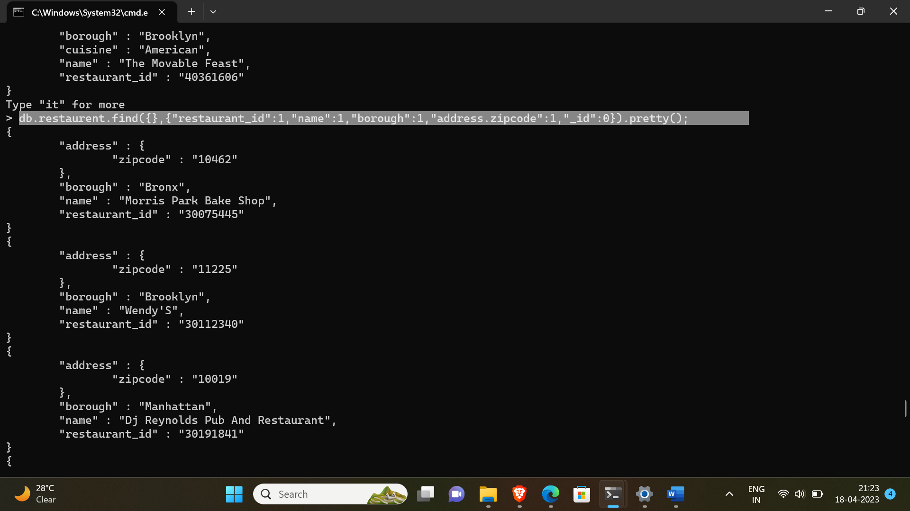

5. Write a MongoDB query to display all the restaurant which is in the borough Bronx

-> db.restaurent.find({ "borough" : "Bronx"}).pretty();

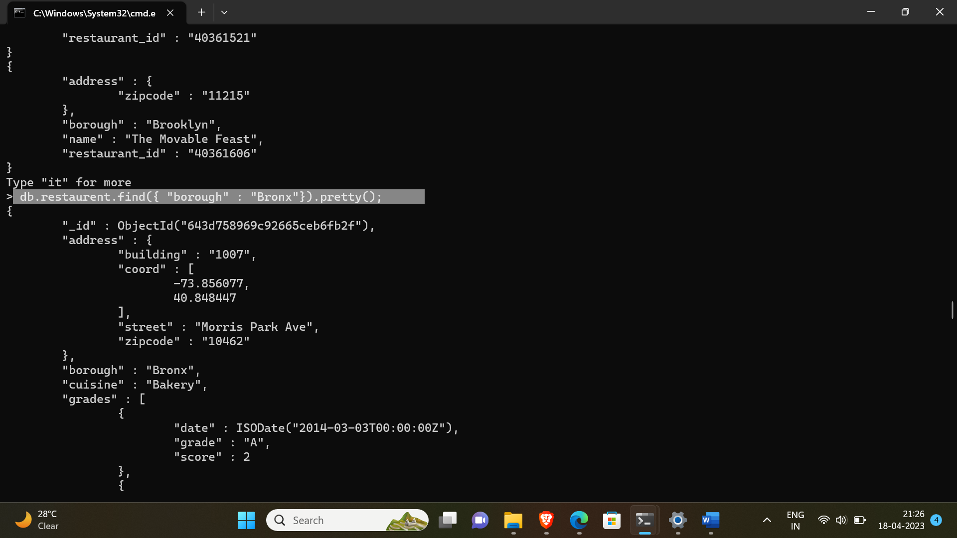

6. Write a MongoDB query to display the first 5 restaurant which is in the borough Bronx.

-> db.restaurent.find({ "borough" : "Bronx"}).pretty().limit(5);

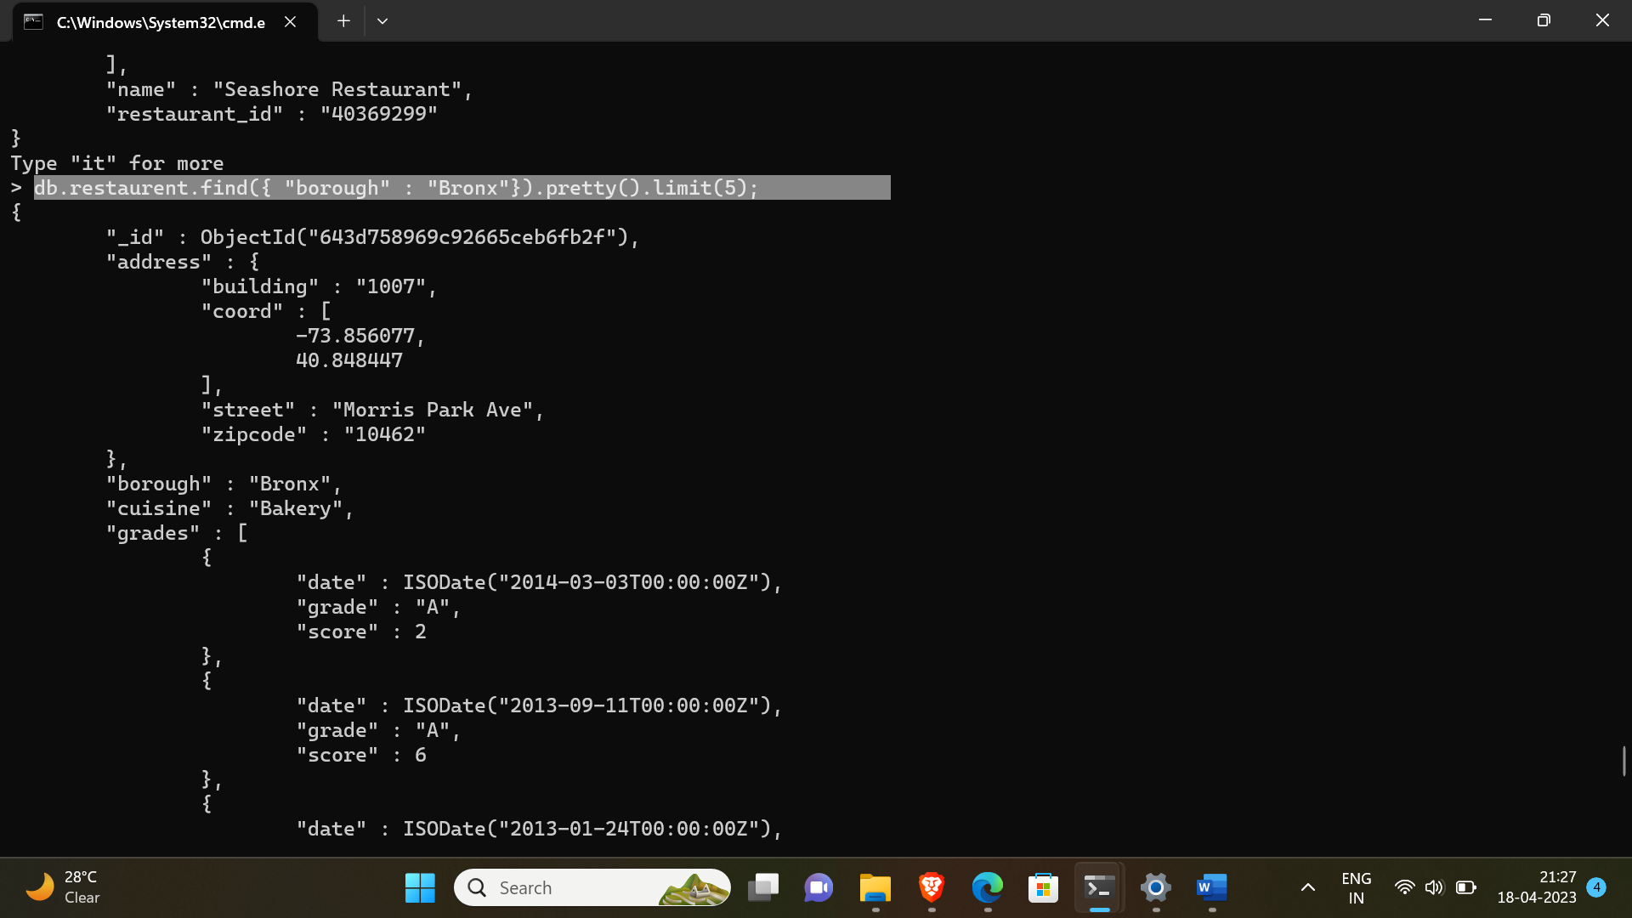

7.Write a MongoDB query to display the next 5 restaurants after skipping first 5 which are in

the borough Bronx.

-> db.restaurent.find({ "borough" : "Bronx"}).pretty().skip(5).limit(5);

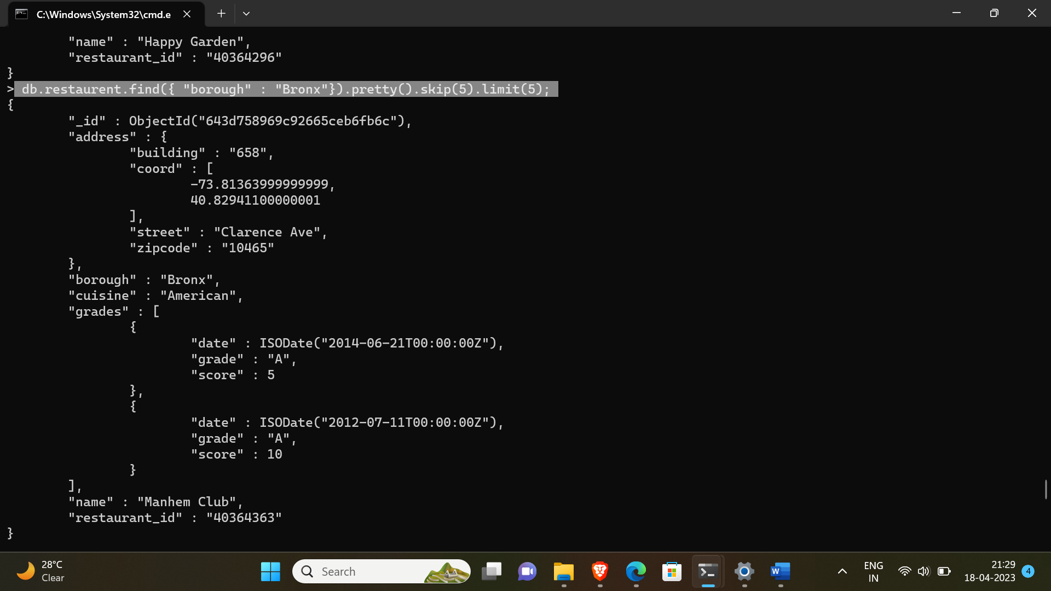

8. Write a MongoDB query to find the restaurants who achieved a score more than 90.

-> db.restaurent.find({"grades.score":{$gt:90}}).pretty();

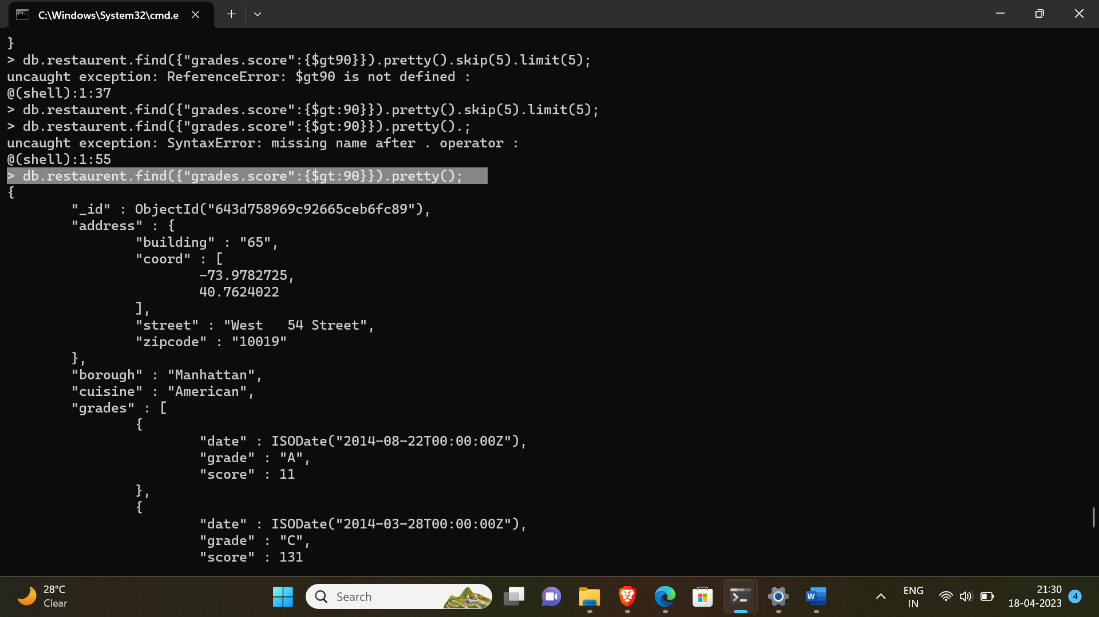

9. Write a MongoDB query to find the restaurants that achieved a score, more than 80 but

less than 100.

-> db.restaurent.find({"grades.score":{$gt:80,$lt:100}}).pretty();

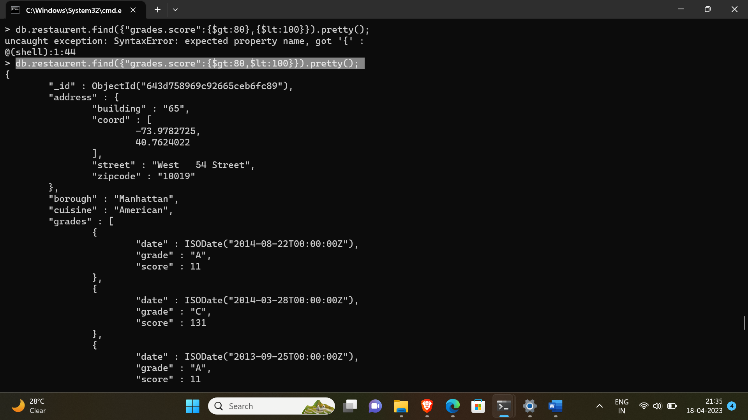

10. Write a MongoDB query to find the restaurants which locate in latitude value less than -

95.754168.

-> db.restaurent.find({"address.coord.0":{$lt:-95.754168}}).pretty();

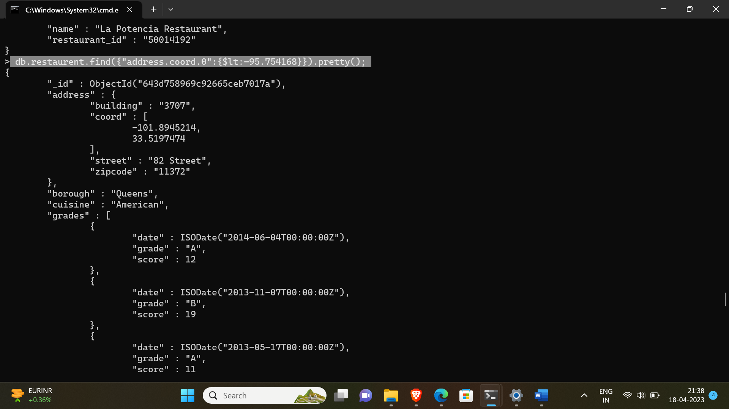

11. Write a MongoDB query to find the restaurants that do not prepare any cuisine of

'American' and their grade score more than 70 and latitude less than -65.754168.

-> db.restaurent.find({"cuisine" : {$ne:"American"},"grades.score":{$gt:70},"address.coord.0":{$lt:-65.754168}}).pretty();

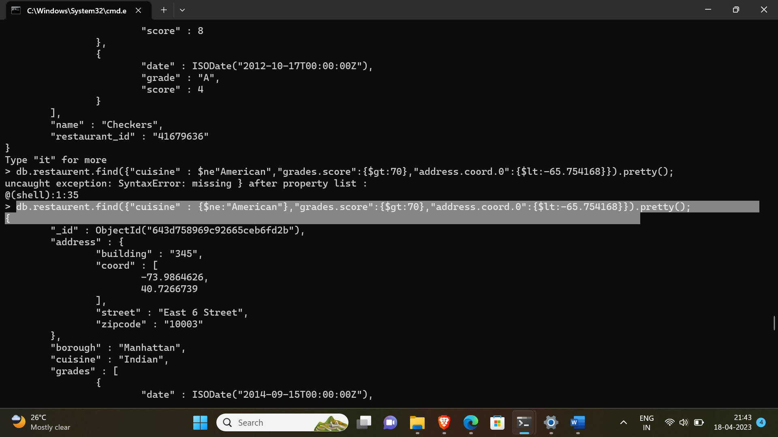

12. Write a MongoDB query to find the restaurants which do not prepare any cuisine of

'American' and achieved a score more than 70 and located in the longitude less than -

65.754168.

-> db.restaurent.find({"cuisine" : {$ne:"American"},"grades.score":{$gt:70},"address.coord.0":{$lt:-65.754168}}).pretty();



13. Write a MongoDB query to find the restaurants which do not prepare any cuisine of

'American ' and achieved a grade point 'A' not belongs to the borough Brooklyn. The

document must be displayed according to the cuisine in descending order.

-> db.restaurent.find({"cuisine" : {$ne:"American"},"grades.grade":"A", "borough" : {$ne:"Brooklyn"}}).sort({cuisine:-1}).pretty();

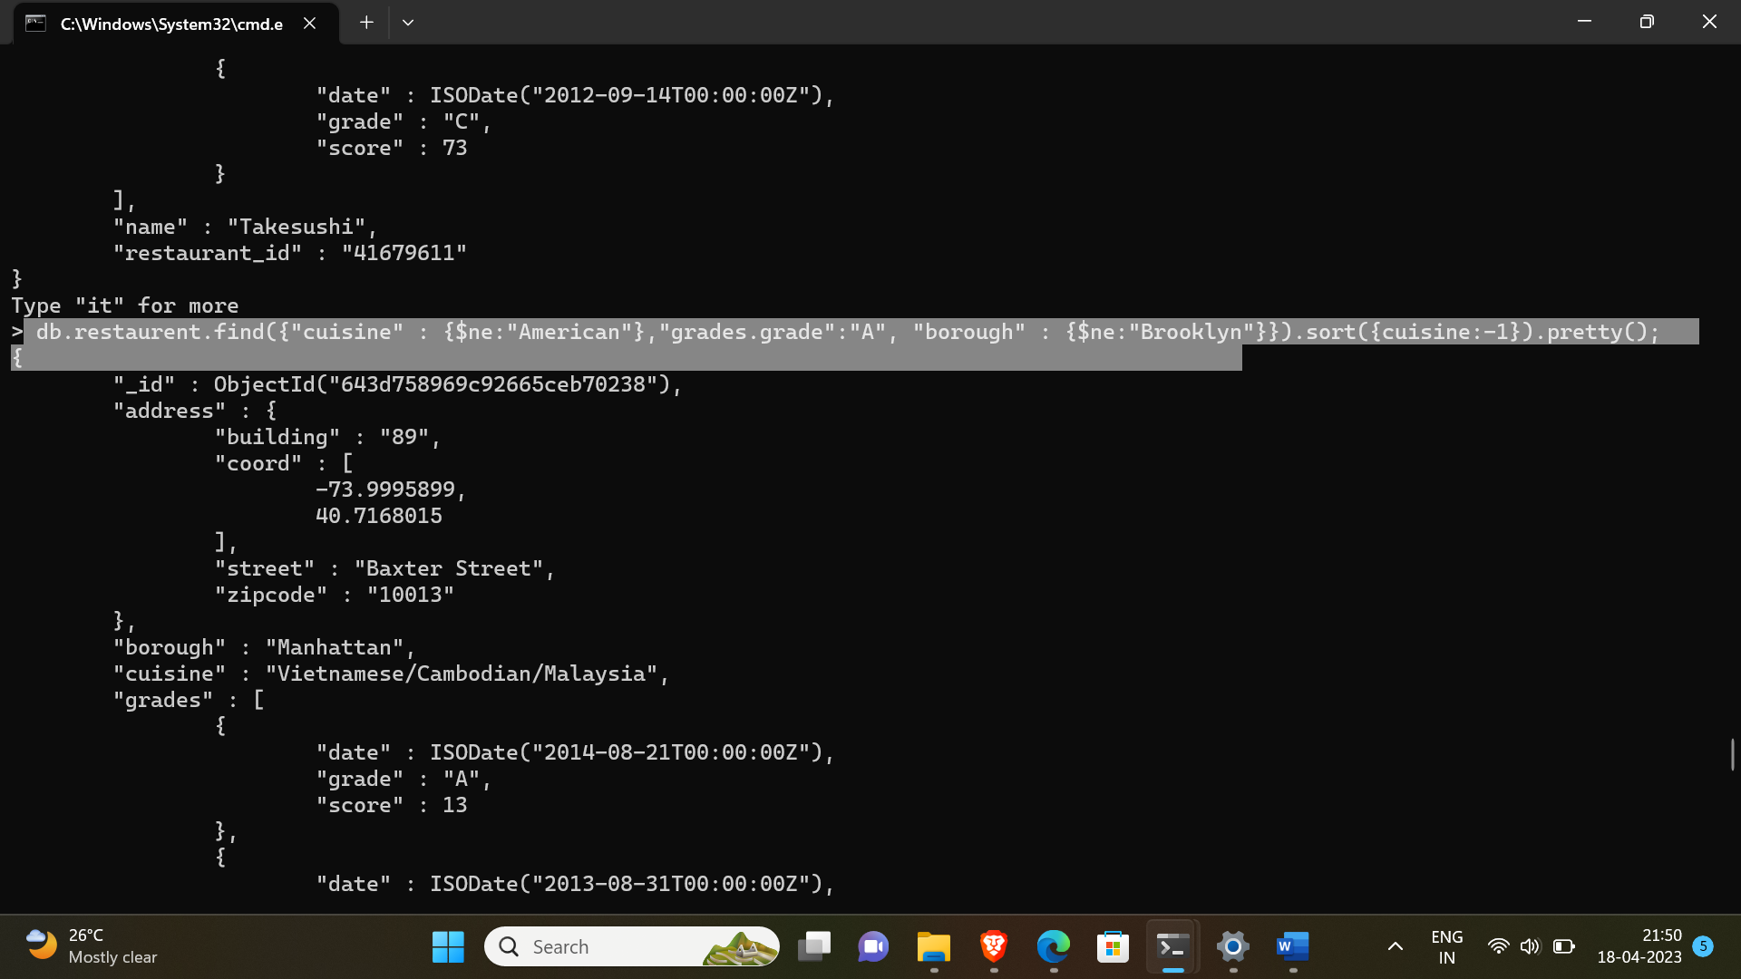

14. Write a MongoDB query to find the restaurant Id, name, borough and cuisine for those

restaurants which contain 'Wil' as first three letters for its name.

-> db.restaurent.find({name:/^Wil/},{"restaurant_id":1,"name":1,"borough":1,"cuisine":1}).pretty();

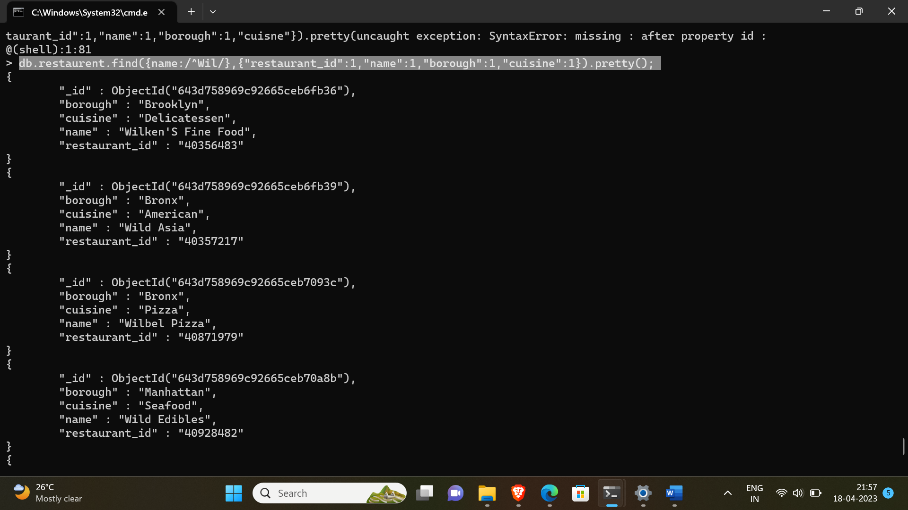

15. Write a MongoDB query to find the restaurant Id, name, borough and cuisine for those

restaurants which contain 'ces' as last three letters for its name.

-> db.restaurent.find({name:/ces$/},{"restaurant_id":1,"name":1,"borough":1,"cuisine":1}).pretty();

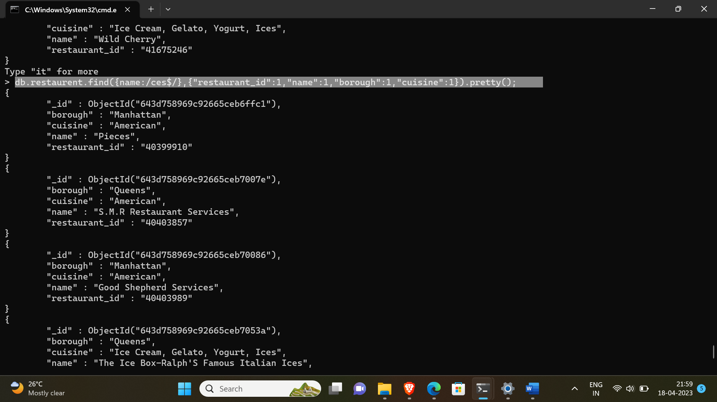

16. Write a MongoDB query to find the restaurant Id, name, borough and cuisine for those

restaurants which contain 'Reg' as three letters somewhere in its name.

-> db.restaurent.find({name:/Reg/},{"restaurant_id":1,"name":1,"borough":1,"cuisine":1}).pretty();

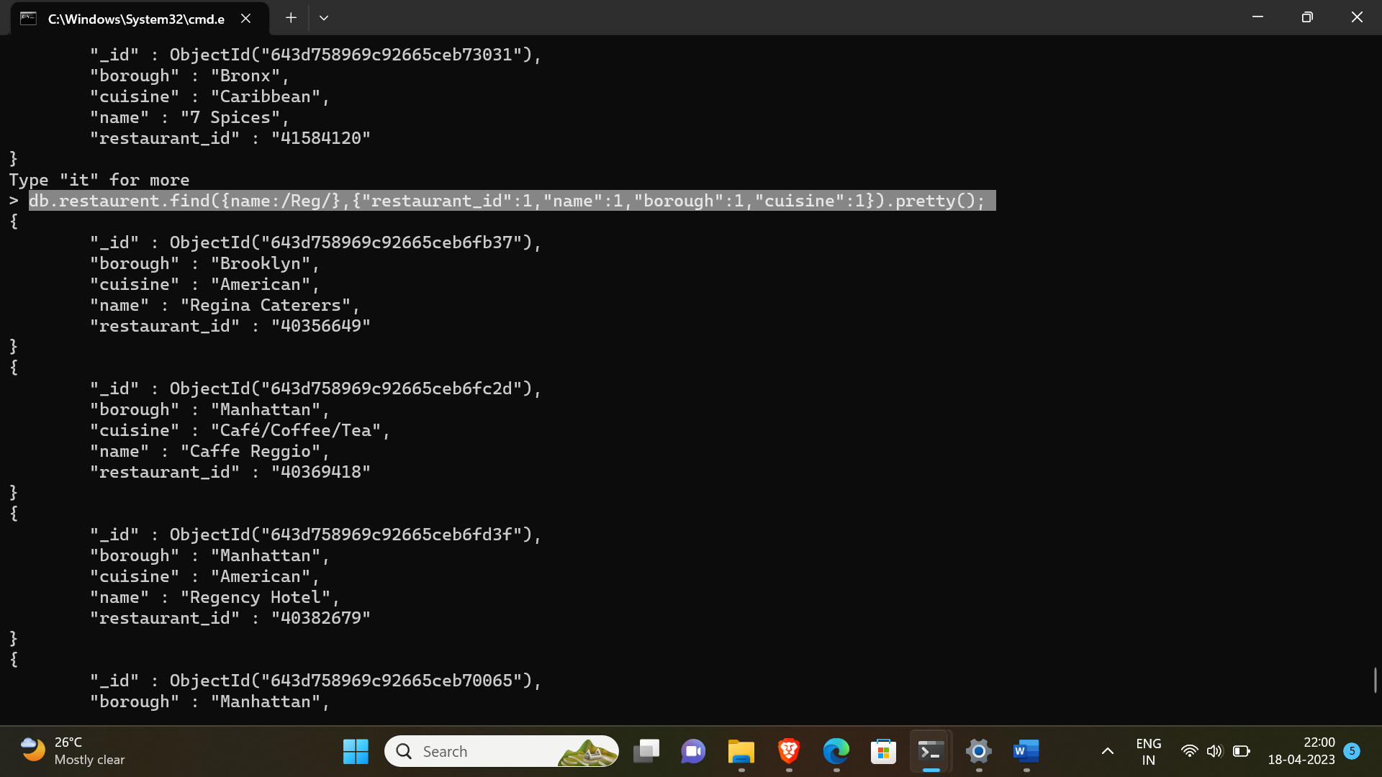

17. Write a MongoDB query to find the restaurants which belong to the borough Bronx and

prepared either American or Chinese dish.

-> db.restaurent.find({"borough":"Bronx",$or:[{"cuisine":"American"},{"cuisine":"Chinese"}]}).pretty();

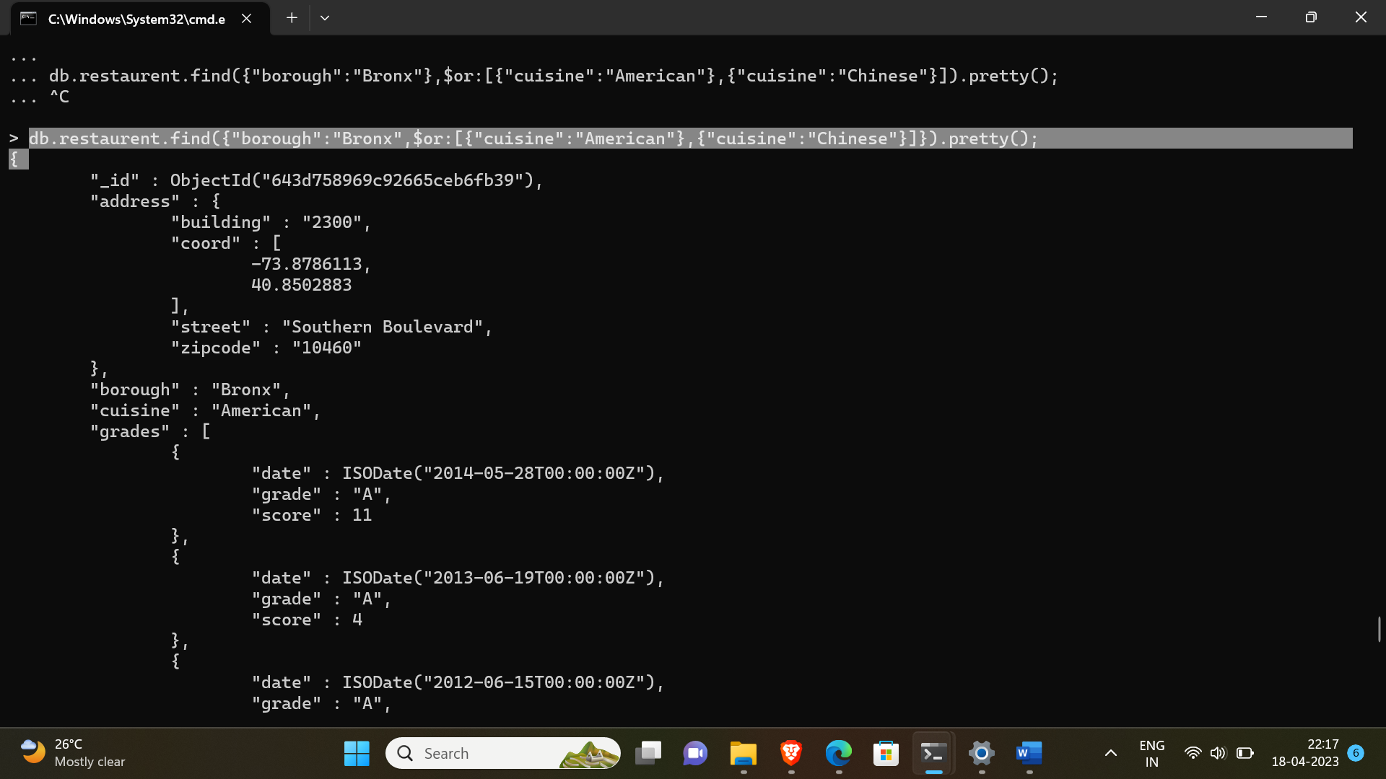

18. Write a MongoDB query to find the restaurant Id, name, borough and cuisine for those

restaurants which belong to the borough Staten Island or Queens or Bronxor Brooklyn.

-> db.restaurent.find({$or:[{"borough":{$ne:"Staten Island"}},{"borough" : {$ne:"Bronx"}},{"borough":{$ne:"Queens"}},{"borough" :{$ne:"Brooklyn"}}]} ,{"restaurant_id":1,"name":1,"borough":1,"cuisine":1}).pretty();

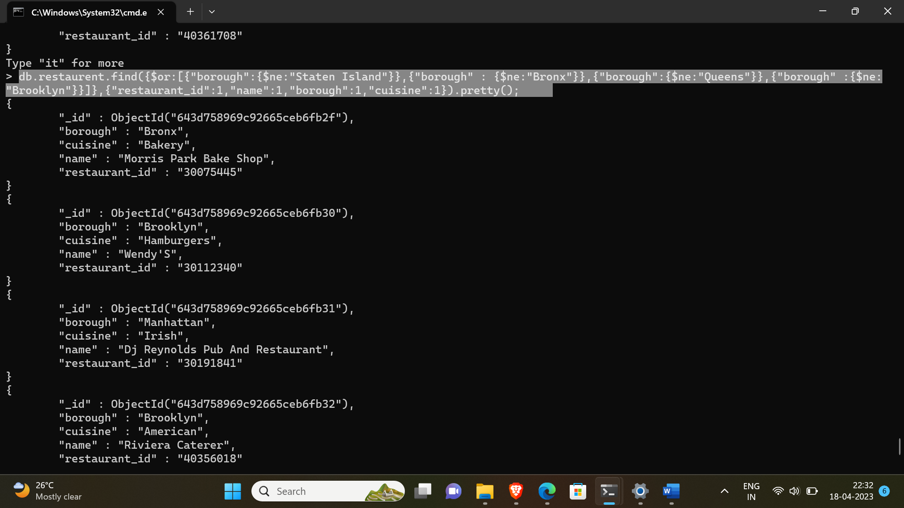

19. Write a MongoDB query to find the restaurant Id, name, borough and cuisine for those

restaurants which are not belonging to the borough Staten Island or Queens or Bronx or

Brooklyn.

-> db.restaurent.find({$or:[{"borough":{$ne:"Staten Island"}},{"borough" : {$ne:"Bronx"}},{"borough":{$ne:"Queens"}},{"borough" :{$ne:"Brooklyn"}}]} ,{"restaurant_id":1,"name":1,"borough":1,"cuisine":1}).pretty();



20. Write a MongoDB query to find the restaurant Id, name, borough and cuisine for those

restaurants which achieved a score which is not more than 10.

-> db.restaurent.find({"grades.score":{$not:{$gt:10}}},{"restaurant_id":1,"name":1,"cuisine":1,"borough":1}).pretty();

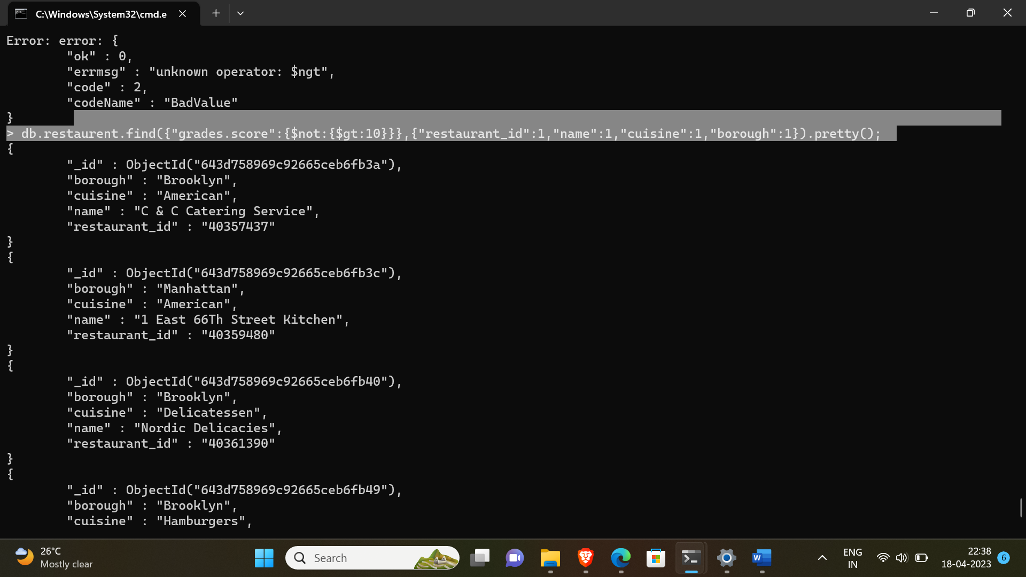

21. Write a MongoDB query to find the restaurant Id, name, borough and cuisine for those

restaurants which prepared dish except 'American' and 'Chinees' or restaurant's name begins

with letter 'Wil

-> db.restaurent.find({$or:[{name:/^Wil/},{$and:[{"cuisine":{$ne:"American"}},{"cuisine":{$ne:"Chinees"}}]}]},{"restaurant_id":1,"name":1,"borough":1,"cuisine":1}).pretty();

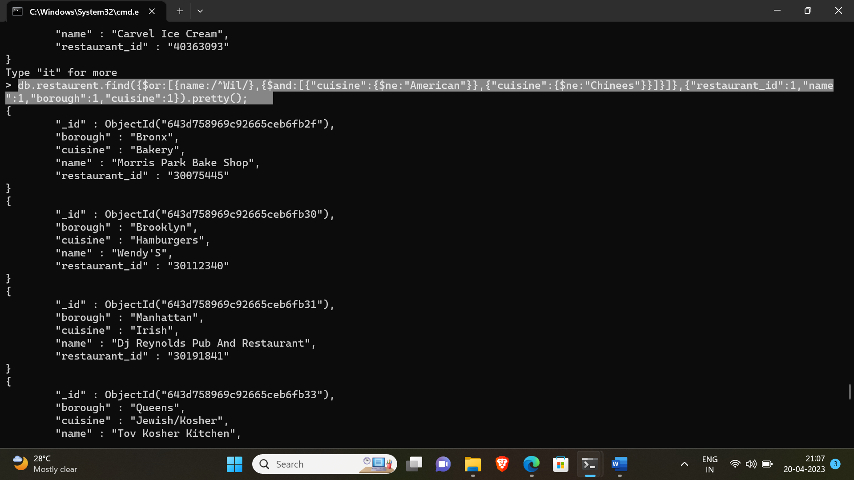

22. Write a MongoDB query to find the restaurant Id, name, and grades for those restaurants

which achieved a grade of "A" and scored 11 on an ISODate "2014-08-11T00:00:00Z"

among many of survey dates.

-> db.restaurent.find({grades:{$elemMatch:{grade:"A",score:11,date:ISODate("2014-08-11T00:00:00Z")}}},{restaurant_id:1,name:1,grades:1}).pretty();

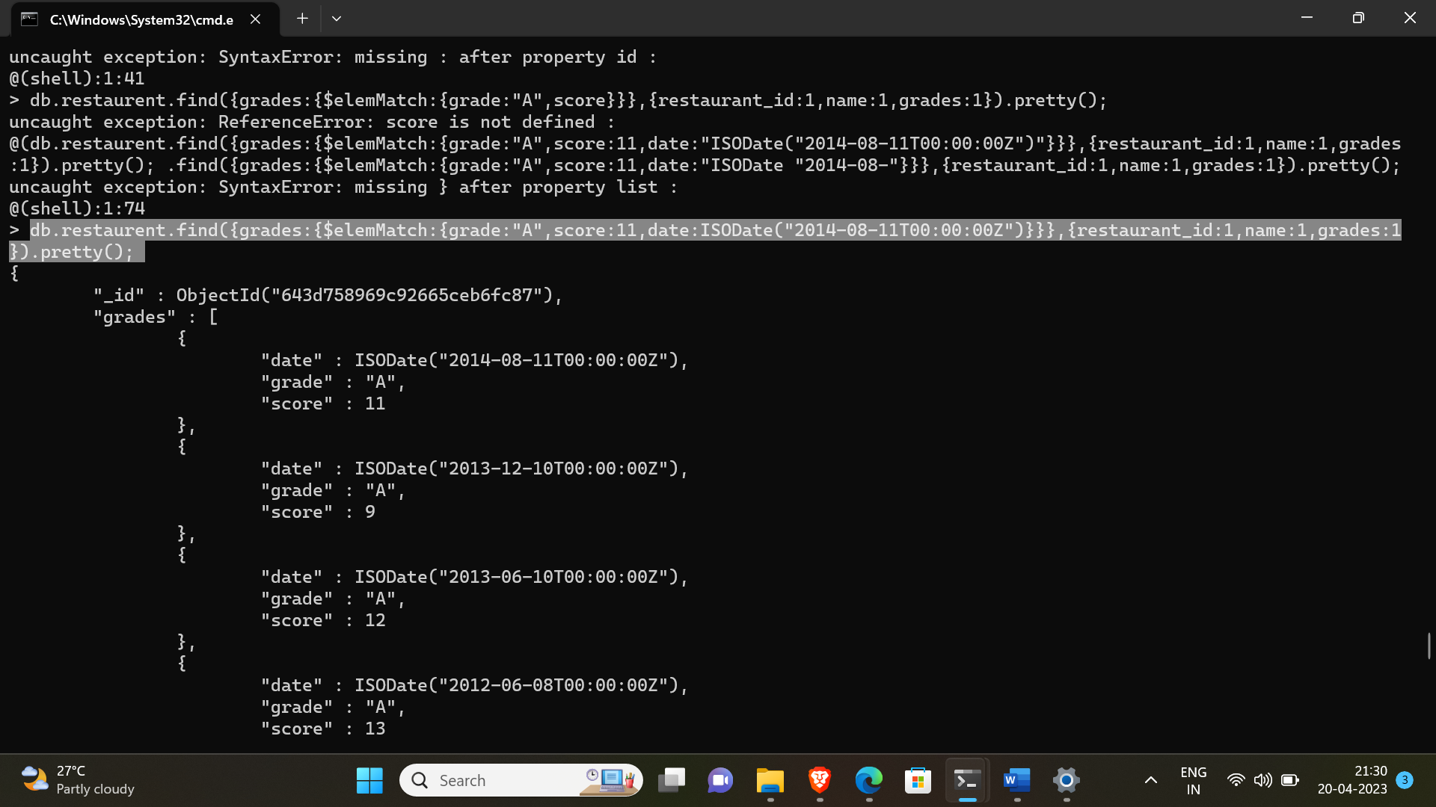

23. Write a MongoDB query to find the restaurant Id, name and grades for those restaurants

where the 2nd element of grades array contains a grade of "A" and score 9 on an ISODate

"2014-08-11T00:00:00Z".

-> db.restaurent.find({"grades.1.grade":"A","grades.1.score":9,"grades.1.date":ISODate("2014-08-11T00:00:00Z")},{restaurant_id:1,name:1,grades:1}).pretty();

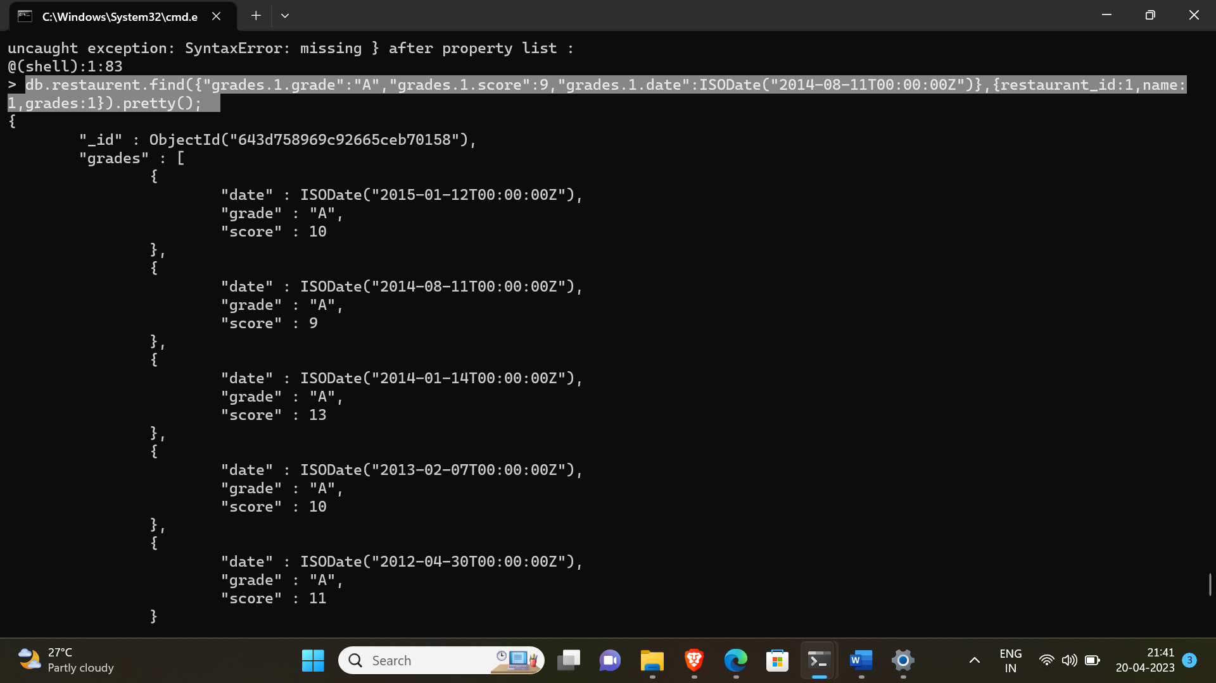

24. Write a MongoDB query to find the restaurant Id, name, address and geographical

location for those restaurants where 2nd element of coord array contains a value which is

more than 42 and upto 52.

-> db.restaurent.find({"address.coord.1":{$gt:42,$lte:52}},{restaurant_id:1,name:1,"address.coord":1}).pretty();

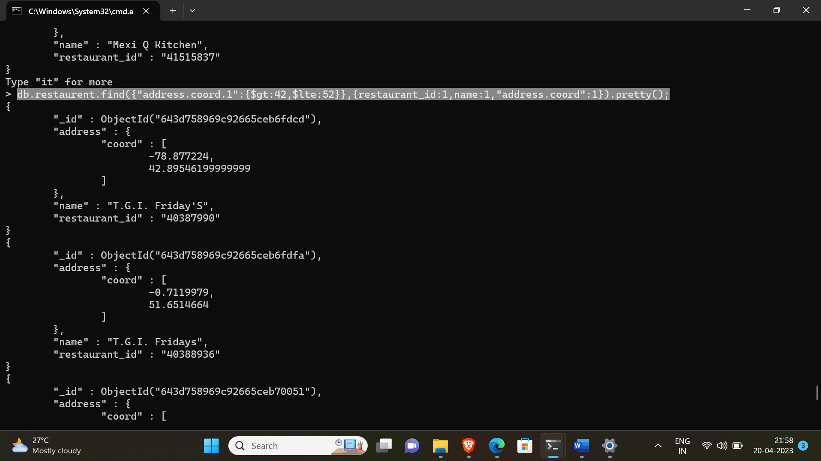

25. Write a MongoDB query to arrange the name of the restaurants in ascending order along

with all the columns.

-> db.restaurent.find().sort({name:1}).pretty();

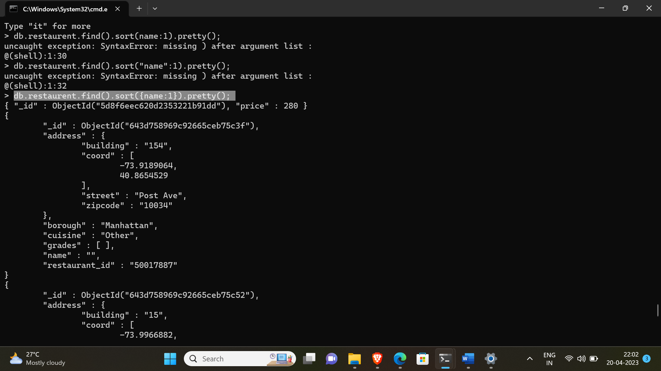

26. Write a MongoDB query to arrange the name of the restaurants in descending along with

all the columns.

-> db.restaurent.find().sort({name:-1}).pretty();

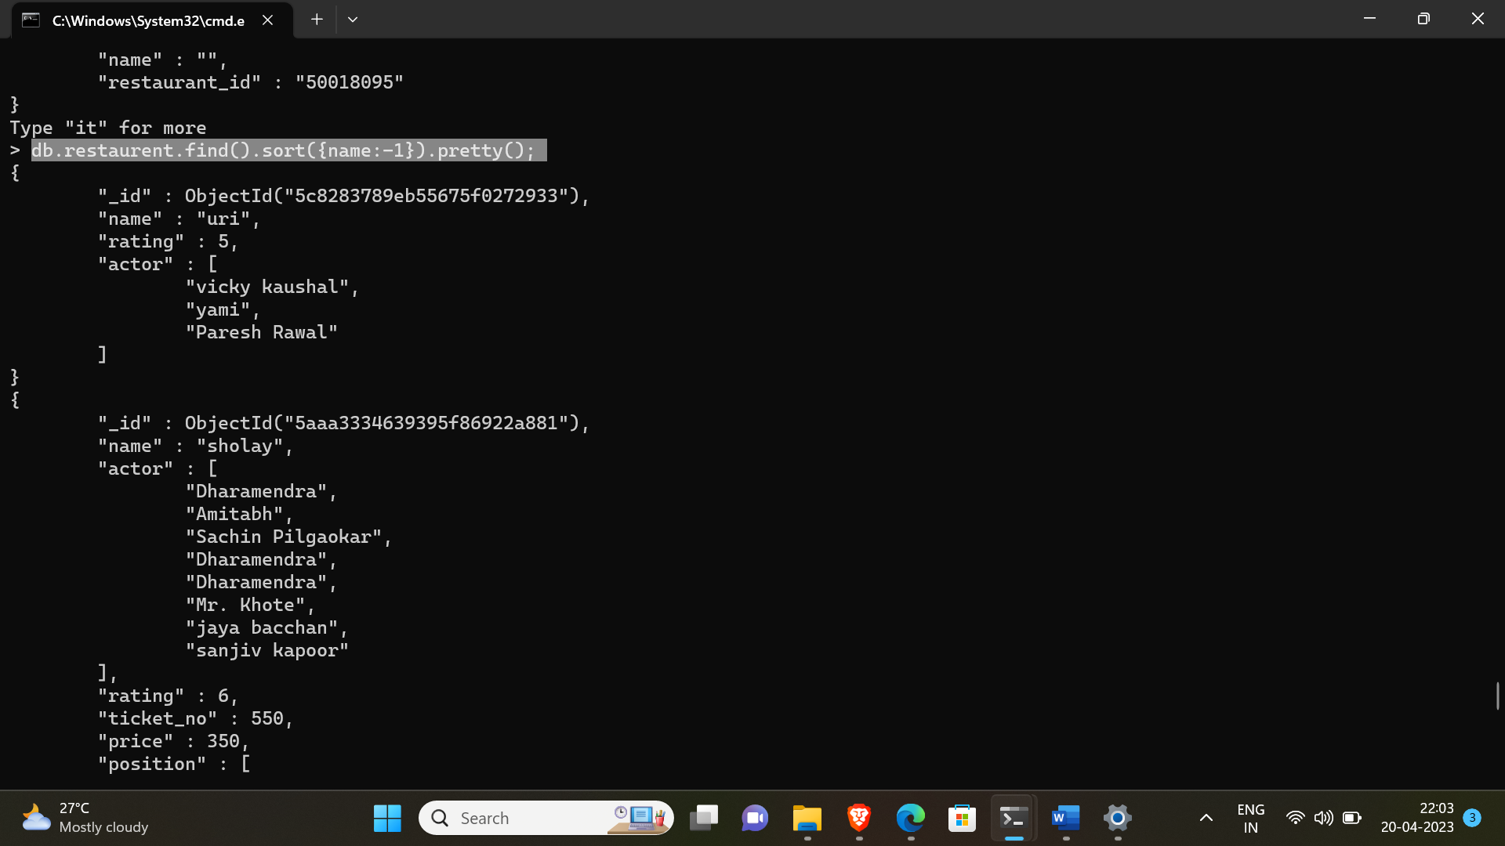

27. Write a MongoDB query to arranged the name of the cuisine in ascending order and for

that same cuisine borough should be in descending order.

-> db.restaurent.find().sort({borough:1},{cuisine:-1}).pretty();

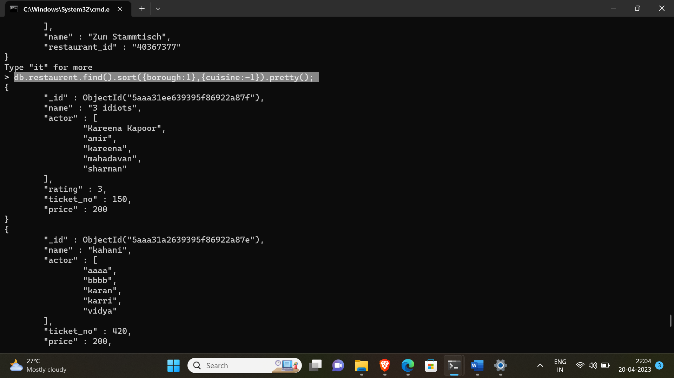

28. Write a MongoDB query to know whether all the addresses contains the street or not.

-> db.restaurent.find({“address.street”:{$exists:true}}).pretty();

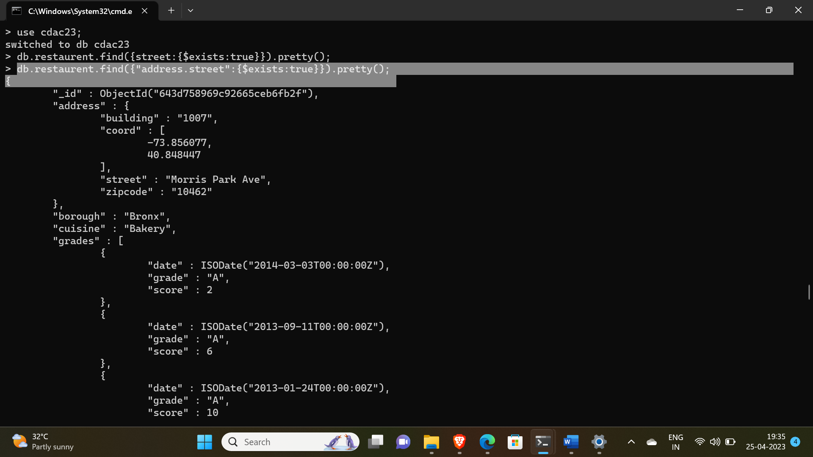

29. Write a MongoDB query which will select all documents in the restaurants collection

where the coord field value is Double.

-> db.restaurent.find({"address.coord":{$type:"double"}}).pretty();

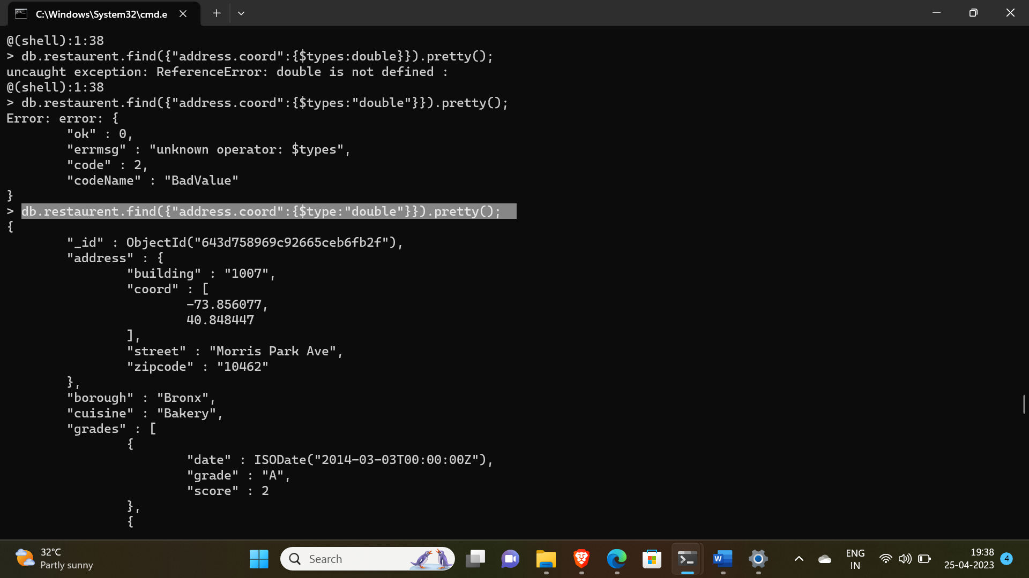

30. Write a MongoDB query which will select the restaurant Id, name and grades for those

restaurants which returns 0 as a remainder after dividing the score by 7.

-> db.restaurent.find({"grades.score":{$mod:[7,0]}},{restaurant_id:1,name:1,grades:1}).pretty();

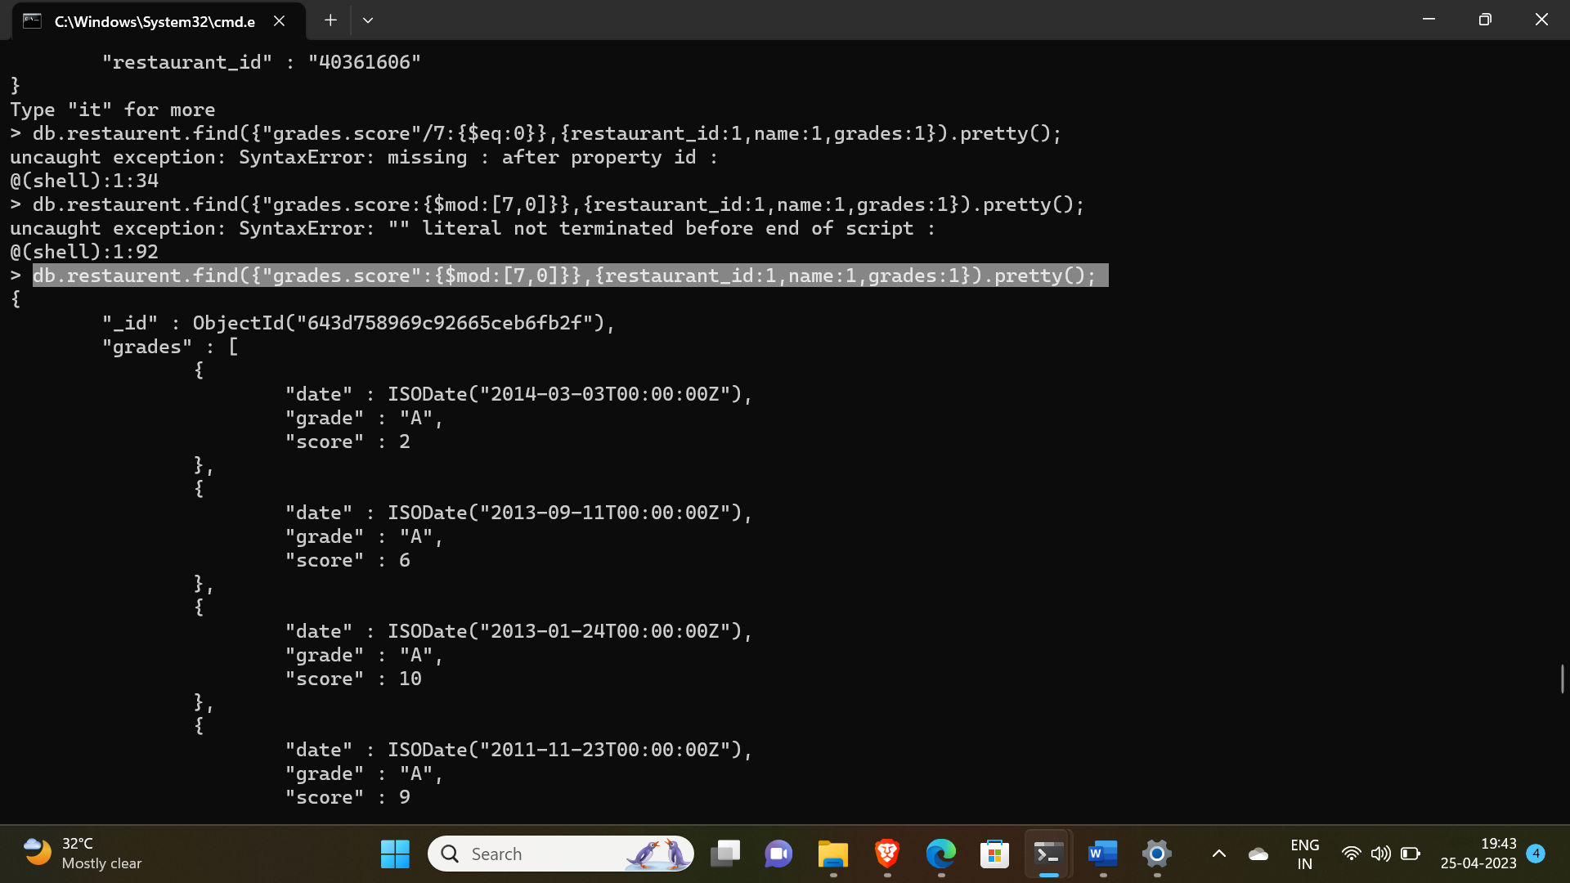

31. Write a MongoDB query to find the restaurant name, borough, longitude and altitude and

cuisine for those restaurants which contains 'mon' as three letters somewhere in its name.

-> db.restaurent.find({name:{$regex:/mon/}},{name:1 ,borough:1, cuisine:1, "address.coord.0":1,"address.coord.1":1}).pretty();

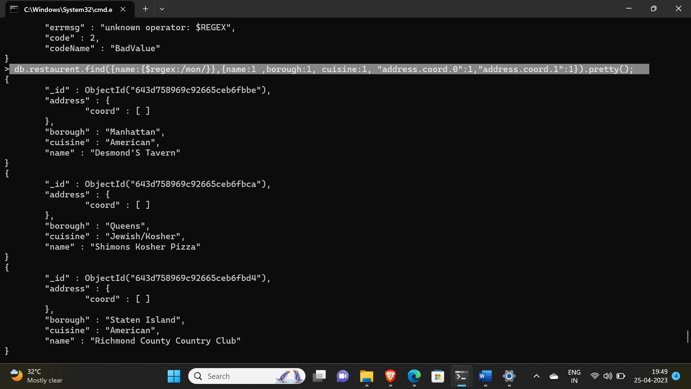

32. Write a MongoDB query to find the restaurant name, borough, longitude and latitude and

cuisine for those restaurants which contain 'Mad' as first three letters of its name.

-> db.restaurent.find({name:{$regex:/^Mad/}},{name:1 ,borough:1, cuisine:1, "address.coord.0":1,"address.coord.1":1}).pretty();